IdeAir: IoT-Based System for Indoor Air Quality Control
Gleiston Guerrero-Ulloa^{1,2} [0000-0001-5990-2357], Alex Andrango-Catota¹ [0000-0002-0965-7522], Martín Abad-Alay¹ [0000-0002-4585-2878], Miguel J. Hornos² [0000-0001-5722-9816] and Carlos Rodríguez-Domínguez² [0000-0001-5626-3115].
¹ Faculty of Engineering Science, State Technical University of Quevedo, 120501 Los Ríos, Ecuador
{gguerrero, alex.andrango2016, martin.abad2016}@uteq.edu.ec
² Higher Technical School of Computer and Telecommunications Engineering,
University of Granada, 18071 Granada, Spain
gleiston@correo.ugr.es, (mhornos, carlosrodriguez}@ugr.es
Abstract. The burning of fossil fuels by cars and household appliances, which make people’s lives easier, causes air quality to deteriorate. Fossil fuel-dependent (water and space) heaters, which help low-income people to live in better conditions, can cause their death. Many solutions to this social problem have been proposed; however, all of them suffer from some drawback that makes their application impossible for households with limited economic resources. This paper proposes the design of IdeAir, a low-cost Internet of Things (IoT)-based indoor air quality monitoring system that aims to reduce the disadvantages of existing systems. IdeAir captures data on harmful gases and determines their concentrations, issuing alarms and notifications according to their concentration levels. Its development has been carried out following the Test-Driven Development Methodology for IoT-Based Systems (TDDM4IoTS), which, together with the tool used (based on this methodology) for the automation of the system development process, has facilitated the work of their developers. Preliminary results on the functioning of IdeAir show a high level of acceptance by potential users.
Keywords: Internet of Things, Development Methodology, Development Tool, Microcontrollers, Air Quality.
- Introduction
Air quality is measured by the amount of toxic gases present in the environment. Gases, such as ozone (O₃) at the earth's surface, nitrogen dioxide (NO₂), carbon monoxide (CO), carbon dioxide (CO₂), ammonia (NH₃), sulphur dioxide (SO₂), benzene (C₆ H₆), ethanol (C₂H₅OH), and particulate matter (PM) are the main environmental pollutants. These gases are produced by the burning of fossil fuels in vehicles, refineries, thermoelectric power generators, and industries [1], and even appliances used at home, such as heaters to heat the environment and water for daily activities. These gases, above certain concentration levels, cause potential harm to human health and even death, in the worst cases. This is especially problematic in populations located at high altitudes, where there is a low concentration of oxygen. The concern to prevent these pollution-related deaths worldwide has prompted the World Health Organisation (WHO) to update the indicators for air quality in order to improve this universal right [2].
Water and space heaters are respectively used to condition the water and room temperature in cold climate homes. These appliances, being fuelled by fossil fuels, emit gases, such as CO, which are hazardous, due to their characteristics (odourless, invisible, tasteless and non-irritating to the eyes) [4]. In fact, CO is considered the silent killer. Hence, this problem and the consequences of the possible misuse of these heaters have concerned several governments, such as those of Argentina [5] and Ecuador [6].
Bommi et al. [7] propose a very important solution to monitor and try to solve the pollution problem. However, due to the investment required, it would not be feasible to implement it in households using space heaters. Another work on air quality monitoring is carried out by Zhou et al. [8], who present a system that issues messages to the user when pollution levels exceed thresholds. In addition, to prevent a serious event, the system can turn on a fan, which would clearly be insufficient in a closed space, such as inside a house.
As a contribution that aims to reduce the number of people suffering from poisoning by hazardous gases, such as CO, CO₂, C₂H₅OH, NO₂, and NH₃, this paper proposes an IoT-based system (IoTS) that is able to detect these gases indoors, and then make appropriate decisions. Therefore, it can be considered as a system to maintain the ideal air, hence its name: IdeAir. After its implementation, a technical demonstration of its execution was carried out in Quito, capital of Ecuador, which has a cold climate and is located at 2850 metres above sea level, where there have been several deaths due to problems with heaters [3].
The main motivation for the development of this IoTS is to provide a reliable solution with a feasible and low-cost implementation to address the social problem described above. Another motivation is to perform an initial validation of the development methodology called TDDM4IoTS [9], since it is a new methodology and one of the few methodologies specifically designed for IoTS development.
The remainder of this paper is organised as follows: Section 2 presents the related work. Section 3 describes the proposed system, as well as the development methodology followed, and the results obtained by applying each of the phases of said methodology. Finally, Section 4 summarises the conclusions and future work.
- Related work
The world is concerned about air pollution and its fatal consequences. This is reflected in the fact that the WHO has issued new guidelines to control air pollution, considering particulate matter (PM) from 2.5µm size upwards [2]. Moreover, the scientific community has carried out some works to help mitigate the consequences of air pollution as well as improve air quality, which we will present in this section.
Considering that vulnerable people usually spend a lot of time in indoor environments, where contamination is higher than in outdoor environments [10], solutions have been presented for these spaces. Bommi et al. [7] aim to control air pollution by reducing the toxicity of gases produced by combustion through a physical-chemical process that generates oxygen.
The work of Liu et al. [11] is related to pollution monitoring, since they monitor CO₂ and PM_{2.5}, among other parameters. In terms of pollutant monitoring, there is also AirSensEUR, which consists of a plug-and-play interoperable sensor node, designed as an open multisensor platform whose investment is around 1000 euros [12].
Taştan & Gökozan [13] propose e-nose, a mobile real-time indoor air quality monitoring system. It is able to measure various air parameters, such as CO₂, CO, NO₂, PM₁₀, temperature and humidity. However, the only way to alert the user about dangerous pollution levels is through notifications sent to the mobile application. Another related work is that of Azma et al. [14], which provides air quality readings using low-cost sensors.
Although all the works reviewed provide solutions to help people prevent from environmental conditions harmful to their health, each of them has some characteristic that makes it impractical to be implemented in low-income households. In the case of the systems presented respectively by Bommi et al. [7] and Liu et al. [11], their main disadvantage is the high investment required. In addition, the laser used to obtain oxygen in the former must be activated manually when the CO value exceeds a threshold value, while the latter is intended for smart buildings. Moreover, the analysed systems, except that of Bommi et al. [7], do not have adequate mechanisms to try to improve air quality. Another disadvantage of all the reviewed works [7], [11]–[14] is the limitation of the means used to send notifications and alerts on air quality, since they only do so through the mobile application. As notifications are sent by email in the system proposed by Azma et al. [14], these are not very effective in emergency situations.
To counteract the disadvantages of the mentioned systems, we have developed a proof of concept for IdeAir, which is a low-cost IoTS. IdeAir consists of: (1) a device to be deployed inside the home to detect and control the pollution, in addition to emit notifications and alerts, (2) a mobile application to configure the device, view real-time data and receive notifications and alerts on pollution levels, and (3) a web application that, in addition to having the same functions as the mobile application, serves to view reports of the data captured by the system and additional information from IdeAir.
- Proposed system
The system we propose, called IdeAir, in addition to providing information on air quality levels, alerts users in several ways, depending on the detected air pollution levels. For this work, four levels of CO have been considered to determine air quality, as shown in Table 1. In addition, for each level, the system displays the corresponding message on its LCD screen.
Table 1. Air quality levels.
Level | Quality | Concentration (ppm) | Notifications (light) | Actions
1 | Good | ≤ 350 | Green | No sound or action.
2 | Moderate | (350, 500] | Blue | Intermittent beeping sound.
3 | Low | (500, 800] | Orange | Medium and constant sound,  open the window.
4 | Poor | > 800 | Red | Loud and constant sound,  open the window,  turn on the fan,  notification in the mobile app.
As shown in Table 1, the highest level (4), with a concentration above 800 ppm (parts per million), has been considered the most dangerous. This table also shows the notifications and actions that have been implemented in IdeAir for the four air quality levels considered.
IdeAir is an IoTS developed to support low-income families who may be at risk due to the use of (space and water) heaters or other similar equipment.
  - Development methodology
IdeAir was developed as a proof of concept, to verify its functionality and effectiveness. The development methodology used was TDDM4IoTS, which specifies 4 roles to be played by the members of the project team [9]. In our case, the project facilitator role was played by an expert in IoTS development. The development team was made up of 2 developers with experience in both IoTS and traditional information systems development. The counsellor role was played alternatively by the two developers, depending on the mastery of each one on the topic to be applied (hardware, graphical user interfaces, web application, mobile application, web services, database, etc.). The advantage of this role play is to try to balance the mastery of the topics needed in IoTS development. The role of users/clients was played by people living in the city of Quito. Therefore, real user requirements were taken into account.
Communication between project members was 90% telematic, as they were geographically dispersed. Meetings were held weekly by videoconference, and both consultations and advice as well as the delivery of software were provided by telematic means. GitHub was used for software version control. Hardware was provided through sporadic face-to-face meetings with the project facilitator, or was directly ordered from suppliers via their respective online purchasing platform.
Project team members tried to carry out the activities involved in the 11 phases considered in the development methodology, in the order specified in TDDM4IoTS [9]. The execution of the activities and their results are shown in the following subsection.
  - Results of applying TDDM4IoTS to this case study
This subsection details the work carried out in each of the development phases specified by TDDM4IoTS [9] in order to obtain the final product.

Preliminary analysis. Although the IoTS developed in this project is a system that can be considered relatively small, it is also necessary to perform the preliminary analysis phase in order to have a solid starting point. This phase, which allows knowing the initial conditions of the environment in which the system will be deployed as well as determining whether it is feasible to meet the requirements demanded by the user, involves the following activities:

Requirements Analysis. It is necessary to have a safe indoor environment at home. Poor installations, daily use or sudden breakdowns of (space and water) heaters can cause irregular amounts of toxic gases to be produced due to poor combustion. When it comes to the home environment, these problems can cause damage to the health of its inhabitants, and even their death. Users need to stay at home resting, doing housework and/or working (as it happened in times of pandemic). To achieve peace of mind for users, the concentration of harmful gases should be determined from the concentration of PM_{2,5} and PM₁₀, and users should be made aware as soon as possible of the danger to which he is exposed so that they can take appropriate precautions, if necessary.
Formal and informal interviews with a group of people living in Quito served to be aware of the existing problem in the households of the people involved. After that, the requirements for IdeAir were established, among which are the following ones:
- Detecting harmful gases, in particular: CO, O₃, CO₂, C₂H₅OH, NO₂, and NH₃.
- Alerting users who are inside the home.
- Alerting users who are away from home.
- Causing the detected gases to be dissipated into the environment and/or expelled to the outside.
Once the system requirements are known, it can be determined how to satisfy them through an appropriate solution.
Technology analysis. All the points raised by the methodology in this activity were answered positively. In other words, the necessary hardware resources were available. These resources are cheap and effective in fulfilling their functions. The software tools for the configuration of the IoTS hardware being presented are available to all and free of charge, such as Arduino IDE and TDDT4IoTS (Test-Driven Development Tool for IoTS) [15].
In this methodology activity, the different existing options for both hardware and software components were compared. The main characteristics that determined which ones to use for this project were: popularity of use, integration between hardware and software, cost, functionalities, learning curve, and mastery by the development team.
The tools selected for the development of this case study were: Apache Netbeans IDE with Java, for the development of the web application; TDDT4IoTS, for the design and generation of models and code for both (web and mobile) applications, as well as for the hardware design and code generation for its configuration (it can record code on the Arduino board); Arduino IDE, to compile and complete the editing of the programming code for the hardware configuration; Android Studio, to complete, compile and generate the apk file of the application for the Android operating system; MySQL, as a database; and WebHost, as a web and database server.
Environment analysis. The device will be deployed in a low-income household. It will be installed in a strategic place near a source of electricity. In these times of pandemic, families were forced to contract internet services for students’ homework and even for adults’ teleworking, so they have this service via Wi-Fi. IdeAir will use this resource to send data to the cloud in real time, using web services. The user will be notified the instant the gas concentration changes. As the environment is silent, one way to alert users in the home will be through sounds, in addition to sending notifications to smartphones that have the mobile application installed.
Feasibility analysis. The study carried out determined the feasibility of the development of IdeAir in the three aspects considered:
- Technical: The skills and competencies of the development team were considered sufficient, given their previous experience. The technologies necessary for the development of the system exist in the market and are easy to acquire. And the estimated development time was considered adequate by the users.
- Economical: The hardware components to be used are low-cost and available on the local market.
- Operational: Once the system is deployed, the user does not need any technical knowledge to keep the system running.

Technology layer design. In this phase, the architecture of the IdeAir system was first obtained, which consists of 3 layers: (1) The top layer is the user interaction layer, where users interact with the web and/or mobile application. (2) The lower layer is the physical layer, which is made up of sensors and actuators, being responsible for controlling the environment. (3) The intermediate layer is the connectivity layer, which processes and stores the information, and uses the WebHost service to send data in real time to be stored in the MySQL database and be displayed on the (web and mobile) applications.
Fig. 1 shows the device design (corresponding to the physical layer) to detect the level of air quality and act appropriately (according to its configuration) to alert the inhabitants of the house and safeguard their health when the air quality is not adequate. The diagram in Fig. 1, which was made using TDDT4IoTS [9], shows the device components, which are: (1) Arduino Uno board, configured to capture the data emitted by the MQ135 and MQ7 sensors, as well as to control (by sending commands) the actuators; (2) active buzzer, for audible notifications; (3) LEDs, for light notifications; (4) ESP3286 NodeMCU, development board to control the DHT11 sensor and for internet connectivity; (5) DHT11 sensor, to measure the temperature and humidity of the environment; (6) MQ135 sensor, to detect CO₂, C₂H₅OH, NH₃ and NO₂; (7) MQ7 sensor, to detect CO; (8) servomotors, to open and close the window; (9) LCD display, to report on indoor air quality; and (10) fans, to expel polluted air.

Fig. 1. IdeAir device design.

Detailed requirements analysis. In this phase, extended use cases [16] were used, as recommended by TDDM4IoTS [9]. Use cases have proven to be a suitable tool for collecting the functional requirements of the system expressed by the users [17]. By doing a thorough analysis of each use case, and using TDDT4IoTS correctly, the development of an IoTS will be easier.

Generation of models, tests and software. In these 3 phases of TDDM4IoTS, the TDDT4IoTS development tool [15] was used. This tool, which is in its first version, is capable of generating even the web application software, including its preliminary graphical user interfaces, from the use cases. It also allows the design of IoT devices and automatically generates most of the software required for their configuration and operation (currently with support for Arduino). At the moment, TDDT4IoTS does not generate the mobile application. Therefore, the software for the graphical user interfaces of the IdeAir mobile app (front-end) was created entirely by the developers.
Regarding the web application, TDDTIoTS uses the model-view-controller pattern to generate source code from the classes diagram. In addition, part of the business logic is transformed into classes to generate and publish the RESTful web services, which will be used to execute the CRUD (create, read, update, delete) basic operations with the database.

Refinement and adaptation of models, tests and software. During model refinement, certain methods were added, such as constructors and other methods not specified in the use cases, as well as a class to specify air quality reference levels.
Fig. 2 shows part of the software architecture (the class diagram), after being generated by TDDT4IoTS and refined for the generation of the IdeAir software and its tests. The automatically generated tests were refined and adapted to the needs of the end users. Integration tests were written by the developers in the detailed requirements analysis phase and executed in the deployment to verify their compliance. To test the correct functioning of the device before its deployment, the environment was contaminated by generating appropriate gases, basically to check the capture and sending of data in real time.
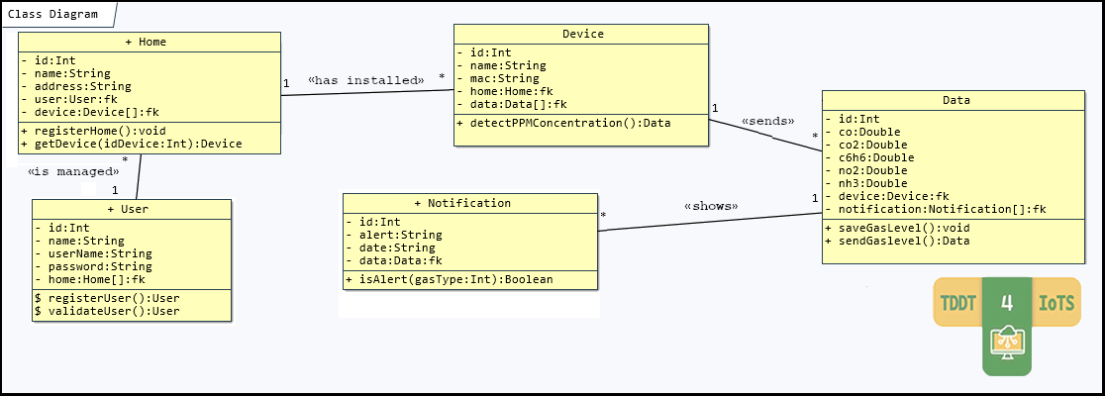
Fig. 2. IdeAir refined class diagram.
In addition, some methods specified in the class diagram had to be implemented by the developers, as their business logic could not be automatically generated in its entirety from the use cases.

Hardware and software deployment. The IdeAir device was deployed in a mock-up of a room that simulated a real room, in order to have a prototype of how the system would work. In it, low-power servomotors were used, which are not sufficient to drive a real window. With this proof of concept, the authors consider that there is sufficient evidence to determine that this system meets the requirements set by the client.
The mobile application allows registering the IdeAir device(s) installed to control it/them, and thus monitor data capture in real time and receive notifications when pollutant gas levels are harmful to health, as well as perform common operations, such as user registering, logging in and displaying information about the system. Fig. 3 shows some screenshots of the mobile application. When the user is authenticated in the mobile application, s/he can access her/his information and options to view the installed devices and captured data, as shown in Fig. 3(a). To register a new device, it can be done through the Device option, which will display a screen like the one shown in Fig. 3(b). Once at least one IdeAir device is registered and the system is up and running, the user can monitor the indoor quality air of the environment in which the device is installed, since s/he will be able to view in real time the data that the device is capturing and sending to the server, as shown in Fig. 3(c).
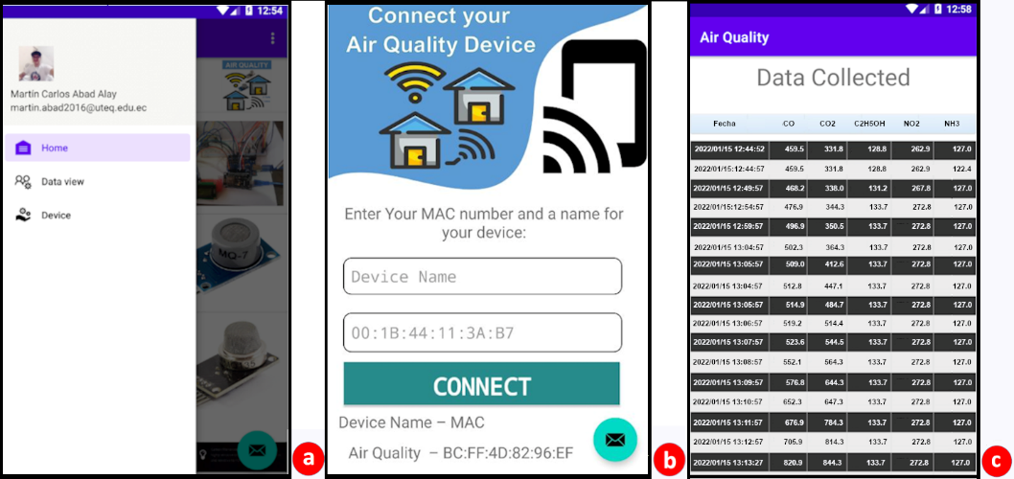
Fig. 3. Screenshots of the mobile application.
- Conclusions and future work
We have presented the implementation of a proof of concept of the IdeAir system, which makes it possible to determine the level of indoor air quality, and to act and alert people when its level of toxicity is dangerous. The use of web services and a WebHost server allows the environmental data captured by IdeAir to be known in real time. When testing IdeAir, users commented that they found it more useful to hear the alarm sound and see the light notifications in the room to alert them about air toxicity levels than the notifications sent to the mobile app.
Following the TDDM4IoTS methodology made developers more orderly in carrying out the activities to develop this IoTS. In addition, the use of the TDDT4IoTS tool helped them to be more productive. In fact, the code generated by the tool was fully used. Another advantage of using this tool is that it saves much of the time spent writing tests, which is a neuralgic part of the Test-Driven Development methodologies, being considered as “wasted time” by most developers.
As future work, after evaluating its functions as a proof of concept, a prototype of the IdeAir system will be developed and deployed to test its operation in a real home. Furthermore, we plan to further improve the TDDT4IoTS tool, especially with regard to the generation of both more code and the user interfaces for the mobile application (for both Android and iOS).

References
- Ezeonyejiaku, C., Okoye, C., Ezeonyejiaku, N., Obiakor, M.: Air Quality in Nigerian Urban Environments: A Comprehensive Assessment of Gaseous Pollutants and Particle Concentrations. Current Applied Science Technology 22(5), (2021).
- World Health Organization: WHO Global Air Quality Guidelines. Particulate Matter (PM2.5 and PM10), Ozone, Nitrogen Dioxide, Sulfur Dioxide and Carbon Monoxide, (2021), https://apps.who.int/iris/bitstream/handle/10665/345329/9789240034228-eng.pdf, last accessed 2021/11/26.
- Rodríguez, A.: A Heater in Bad Condition Caused a Tragedy in the Town Committee. Five Members of a Family Died (in Spanish), https://www.elcomercio.com/actualidad/
quito/intoxicacion-monoxido-carbono-muerte-quito.html, last accessed 2021/11/17.
- Gazis, A., Katsiri, E.: Smart Home IoT Sensors: Principles and Applications - A Review of Low-Cost and Low-Power Solutions. International Journal on Engineering Technologies and Informatics 2(1), 19–23 (2021).
- Gobierno de Mendoza: Instant Heaters are the Main Cause of Carbon Monoxide Poisoning (in Spanish), https://www.mendoza.gov.ar/defensacivil/noticias/los-calefones-instantaneos-son-la-principal-causa-intoxicacion-por-monoxido-de-carbono/, last accessed 2022/03/14.
- National Risk and Emergency Management Service (Servicio Nacional de Gestión de Riesgos y Emergencias): SGR Advises on the Use of Space Heaters (in Spanish), https://www.gestionderiesgos.gob.ec/sgr-aconseja-sobre-el-uso-de-calefones/, last accessed 2021/11/15.
- Bommi, R. M., Monika, V., ArockiaKoncy, A. A., Patra, C.: A Surveillance Smart System for Air Pollution Monitoring and Management. In Hemanth, J., Fernando, X., Lafata, P., Baig, Z. (eds) Lecture Notes on Data Engineering and Communications Technologies, pp. 1407-1418. Springer, Cham (2019).
- Zhou, M., Abdulghani, A. M., Imran, A. M., Abbasi, Q. H.: Internet of Things (IoT) Enabled Smart Indoor Air Quality Monitoring System. In Proceedings of the 2020 International Conference on Computing, Networks and Internet of Things, pp. 89–93. ACM, Sanya, China (2020).
- Guerrero-Ulloa, G., Hornos, M. J., Rodríguez-Domínguez, C.: TDDM4IoTS: A Test-Driven Development Methodology for Internet of Things (IoT)-Based Systems. Communications in Computer and Information Science 1193, 41–55 (2020).
- Shrestha, P. M. et al.: Impact of Outdoor Air Pollution on Indoor Air Quality in Low-Income Homes during Wildfire Seasons. International Journal Environment Research Public Health 16(19), 3535-3555 (2019)
- Liu, Z., Wang, G., Zhao, L., Yang, G.: Multi-Points Indoor Air Quality Monitoring Based on Internet of Things. IEEE Access 9, 70479–70492 (2021).
- Kotsev, A., Schade, S., Craglia, M., Gerboles, M., Spinelle, L., Signorini, M.: Next Generation Air Quality Platform: Openness and Interoperability for the Internet of Things. Sensors 16(3), 403-418 (2016).
- Taştan, M., Gökozan, H.: Real-Time Monitoring of Indoor Air Quality with Internet of Things-Based E-Nose. Applied Sciences 9(16), 3435-3447 (2019).
- Azma Zakaria, N., Zainal Abidin, Z., Harum, N., Chen Hau, L., Salih Ali, N., Azni Jafar, F.: Wireless Internet of Things-Based Air Quality Device for Smart Pollution Monitoring. International Journal of Advanced Computer Science and Applications 9(11), 65–69 (2018).
- Guerrero-Ulloa, G., Carvajal-Suárez, D., Brito-Casanova, G., Pachay-Espinoza, A., Hornos, J.M., Rodríguez-Domínguez, C.: Test-Driven Development Tool for IoT-based System, https://aplicaciones.uteq.edu.ec/tddm4iots/, last accessed 2022/01/02.
- Dar, H. S., Imtiaz, S., Ullah Lali, M. I.: Gamification Tool Design for Reducing Requirements Ambiguity during Elicitation. In: 5th International Conference on Computing and Informatics 2022, ICCI, pp. 080-086. IEEE, New Cairo, Cairo, Egypt (2022).
- Naumcheva, M.: Object-Oriented Approach for Requirements Specification. In Fischbach, J., et al. (eds) Joint Proceedings of REFSQ-2022 Workshops, Doctoral Symposium, and Poster & Tools Track, vol. 3122. Birmingham, UK (2022).

